PARISH NEWSLETTER
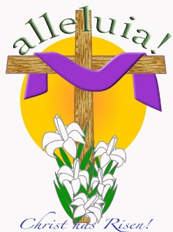
31st. March 2024
Easter Sunday
The Parish Office will be closed this comiing week.
Email: clonmoreoffice.parish@gmail.com
Fr. John: 086-2403787. Email: frjohn51@gmail.com

ANNIVERSARIES – WITH LOVE WE REMEMBER
Saturday 6th. April Ballyconnell 7.30: Joe & Kathleen O’Reilly, Killinure; Claire Keogh, Killinure; Eamonn Coleman
Sunday 7th. Kilquiggan 9.00: James & Norah Clare, Ballynultagh; Vincent Blake Mullinacuffe and his siter Maureen Clifford, and her husband Michael Clifford; Bunclody, form Mullinacuffe
28th. Clonmore 10.30: Thomas Dowling, Minvaud; Dan Lawlor, Ballykilduff and all deceased family members.
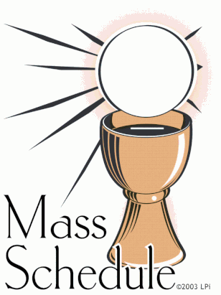
MASS SCHEDULE:
Friday 5th. April: Mass in Killinure at 7.30.

Ballyconnell Bingo will take place in Ballyconnell hall every Sunday at 8.00 pm.

Coolkenno GAA Lotto: Last week’s numbers: 12, 30, 31, 32 No Jackpot winner. Next week’s jackpot €3.300 Next Draw: Monday 1st. April in the Crab Lane. Lucky Dip Winners: Margaret Byrne, Munny; Sandra McNally, Tobinstown; Gerard Doyle, Bagenalstown; William Griffin.
Bingo everty Saturday in Crab Lane Car Park at 3.30
Collections: Weekend: March 23/24
Envelopes: €417 Baskets: €403; Bingo: €445. Envelopes ret.73

PARISH LOTTO: Kildare & Leighlin Co-Op Lotto
Results for Wednesday 27th. March: Numbers: 11, 15, 28, 29
No Winner – Next week’s jackpot €12,000 – 10 Match 3’s - €100 each.
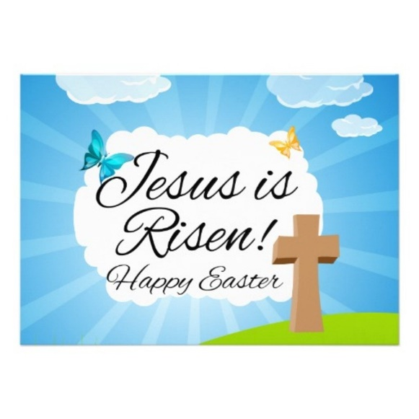
Easter Sunday is the ‘feast of feasts’, a day of joy and happiness as we celebrate the resurrection of Christ. Light a candle and pause for a few moments to become aware of God’s presence. Make the sign of the cross as you pray:
Lord of all life, You are our Hope and our joy, our source of true happiness We have journeyed to Easter and in the most difficult of trials We have renewed our Baptism And proclaimed your resurrection. We embrace with gladness the new life to which you call each one of us. Bless us, our families and all the world, With your constant presence and protection. May we give you thanks every day and share the good news of our faith with all we meet and may the light of our Easter faith. Guide our footsteps into your ways of love, peace and truth Through Christ Our Lord. Amen. In Easter joy we proclaim, Christ is risen! Alleluia, alleluia! If you have Holy Water, use it to bless yourself as you make the sign of the cross. Place your candle safely somewhere prominent in your home as a reminder of the light of Christ among us.

SeniorLine: Would you like someone to talk to? SeniorLine is Ireland’s national telephone service for older people, open every day of the year 10.00 am to 10.00 pm, they can be contacted on Freephone 1800 80 45 91. Callers may feel isolated, alone, wish to discuss a problem in confidence, or for company during their day. SeniorLine’s volunteers are trained to listen, to support, to discuss options and refer the caller to other helpful services available if necessary. So don’t be alone if sharing a problem would help, phone SeniorLine.

Easter Carol Service: There will be an Easter ‘Carol Service’ on Friday 5th April 2024 in the Dominican College Church, Newbridge. Sing-along and listen to hymns old and new, singing our belief in the Lord’s conception, birth, epiphany, transfiguration, suffering, rising, and ascending, and return in glory. The Service is in aid of Lauralynn Children’s Hospice.

The School House Community & Enterprise Centre Rathvilly:
Rathvilly Community Centre Committee presents the “Celtic Brothers” in St. Patrick’s Church Rathvilly on the 28th April 2024 @ 7.00 p.m. (doors open @ 5.30 p.m.). Tickets are €25.00 and are available online or hard copy in Brennan’s Centra, The Post Office, The Pharmacy, The Parish Office, and members of the committee.

The World’s craziest Easter traditions
- On Easter Monday the residents of Haux, France crack more than 4,500 eggs into a gigantic pan to create a massive Easter Omelet that serves over 1,000 people
- Chocolate isn’t much use in the steamy jungles of Papua New Guinea, so Easter trees at the front of the churches are decorated with sticks of tobacco and cigarettes instead
- In the Philippines some devout Catholics have taken to the practice of self-crucifixion and self-flagellation on Easter. Their thinking is that it helps purify them and cleanses them of the sins of the world.
- Easter is known around the world for multi-coloured, decorated eggs. But in Greece you will find only red eggs. Red is the colour of life, you see, as well as a representation of the blood of Christ.
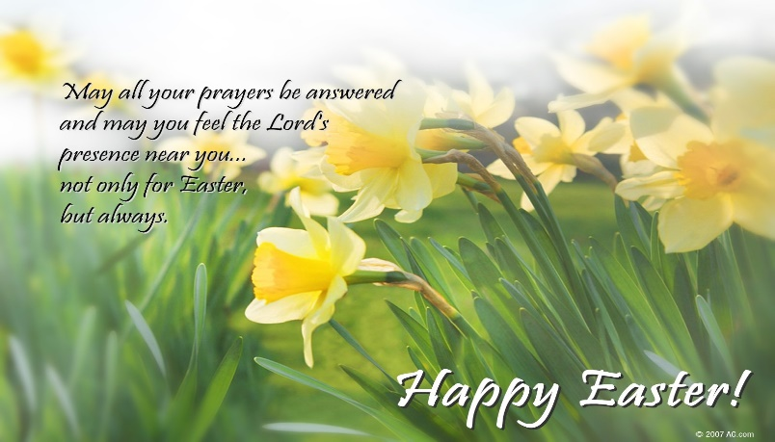

HAVE A WONDERFUL WEEK

